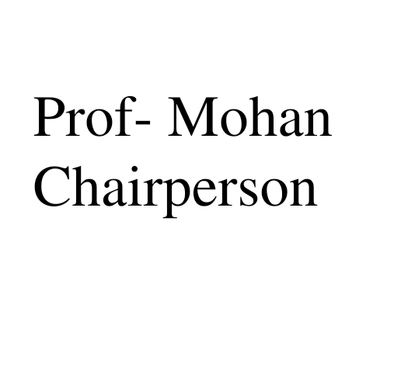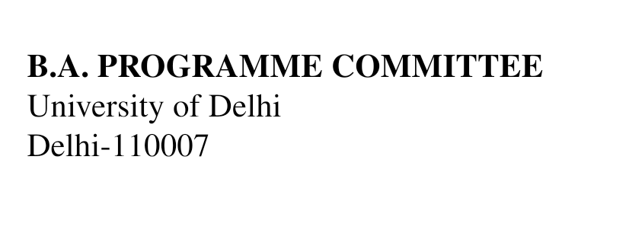

Ref.No.FA/2022/

Dated: 11.04.2022

Dear Mr. Nishant Kumar Singh,

**Subject: Request for setting of Question paper for B.A. Programme May/June 2022**

This is to inform that you have been appointed as the Convener of the following paper. Please inform the concerned examiners and coordinate with them (Board Members). Kindly submit the Question Paper latest by 20th April, 2022 in the office of the B.A. Programme Committee.

**B.A. (Programme) Annual Mode Foundation Course May/June-2022**

| **Annual** | **Unique Paper Code (Mandatory)\*** | **Paper/Title Name** | **Name of Convener with college name, complete address & contact number** | **Name of Paper Setter-I with College Name, Complete Address & Contact Number\*** | **Name of Paper**  **Setter-II with College, Name Complete Address & Contact Number** |
| --- | --- | --- | --- | --- | --- |
| II | B-401 | Contemporary India | Mr. Nishant Kumar Singh- SLC  Ph:- 9968456614  [singhnishant1@gmail.com](mailto:singhnishant1@gmail.com) | Ms. Indu Baghel  Ph:- 9212874248  [indubaghel2010@gmail.com](mailto:indubaghel2010@gmail.com) | - |

In case, the appointed examiner refuses/shows unavailability for the same, he/she is requested to inform the Head of the Department stating the substitute examiner’s name in writing along with his/her consent routed through the College Principal.

With warm regards,

(Prof. Mohan)

Chairperson

B.A. Programme Committee



Room No. 134, Arts Faculty Extension Building, University of Delhi, Delhi -110007

E-mail :- [baprogrammecommittee@yahoo.com](mailto:baprogrammecommittee@yahoo.com)