TEACHING PLAN for Academic Year **2021-22**

**PAPER:** DSE-V History of the USA: Reconstruction of New Age Politics

**SEMESTER:** V

**SESSION:** 2021-22

**TEACHER NAME:** Mr. Nagendra Kumar

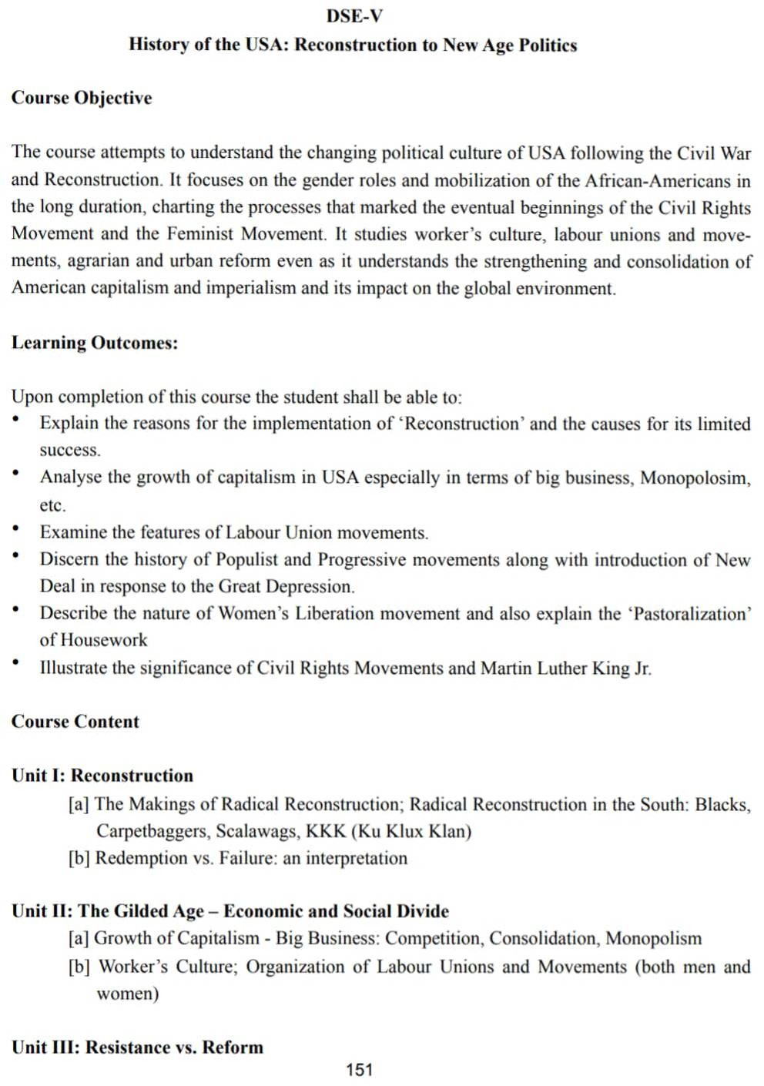

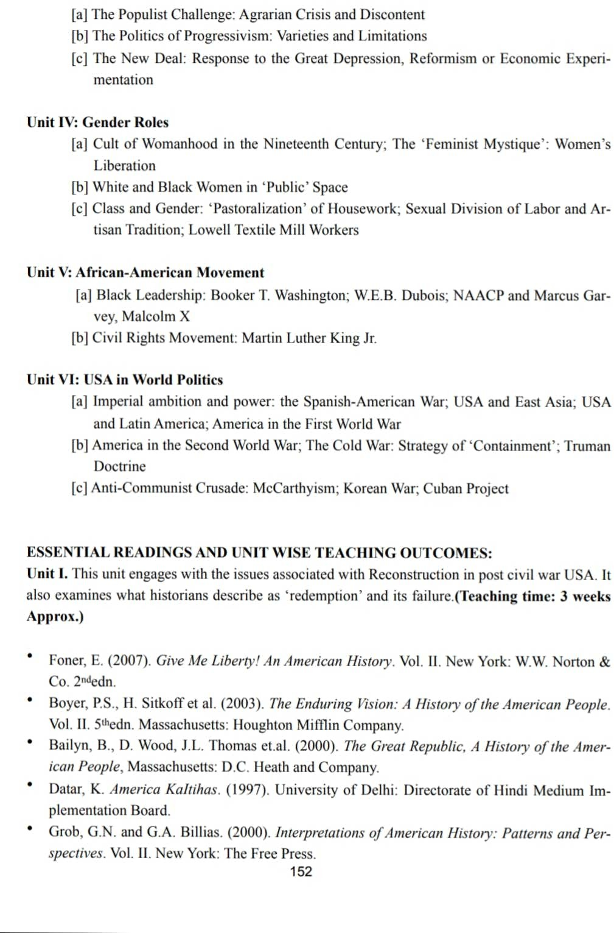

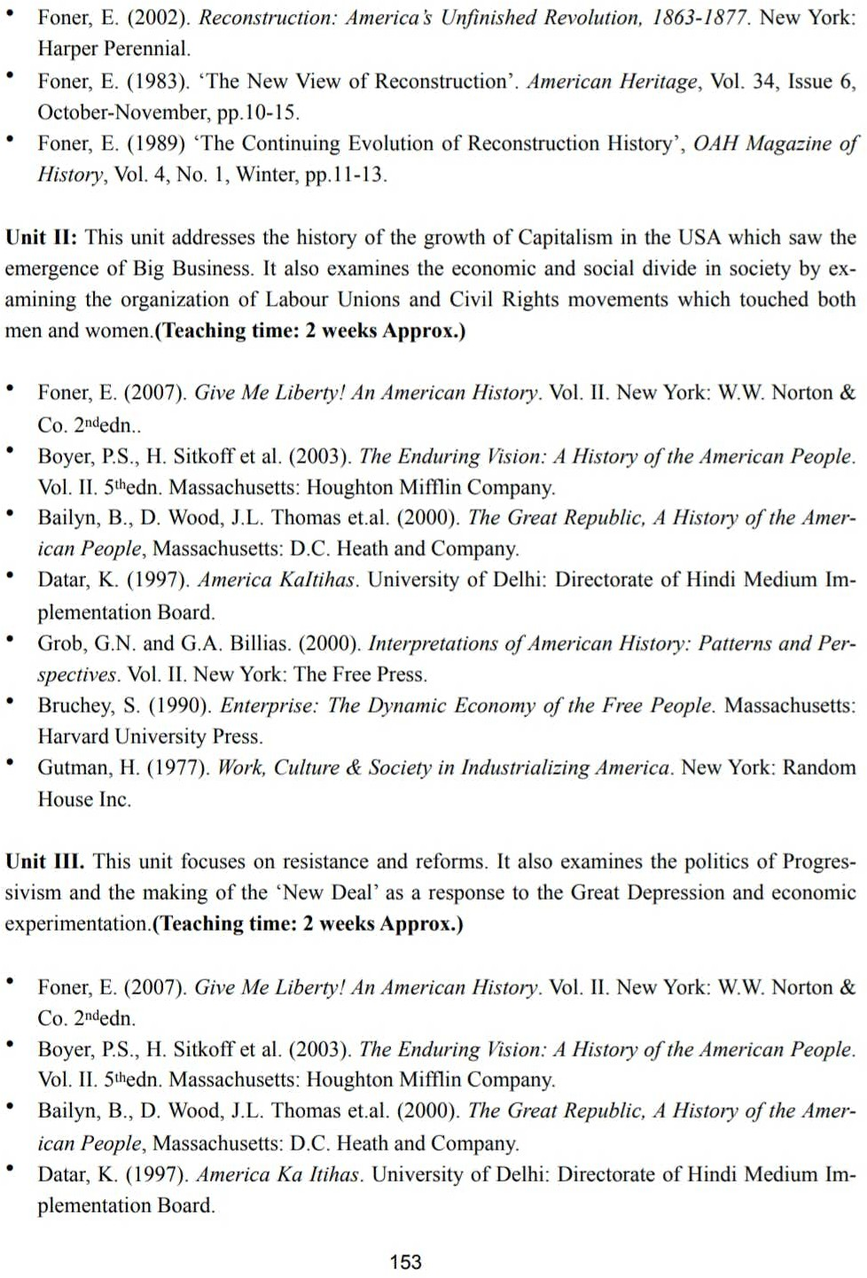

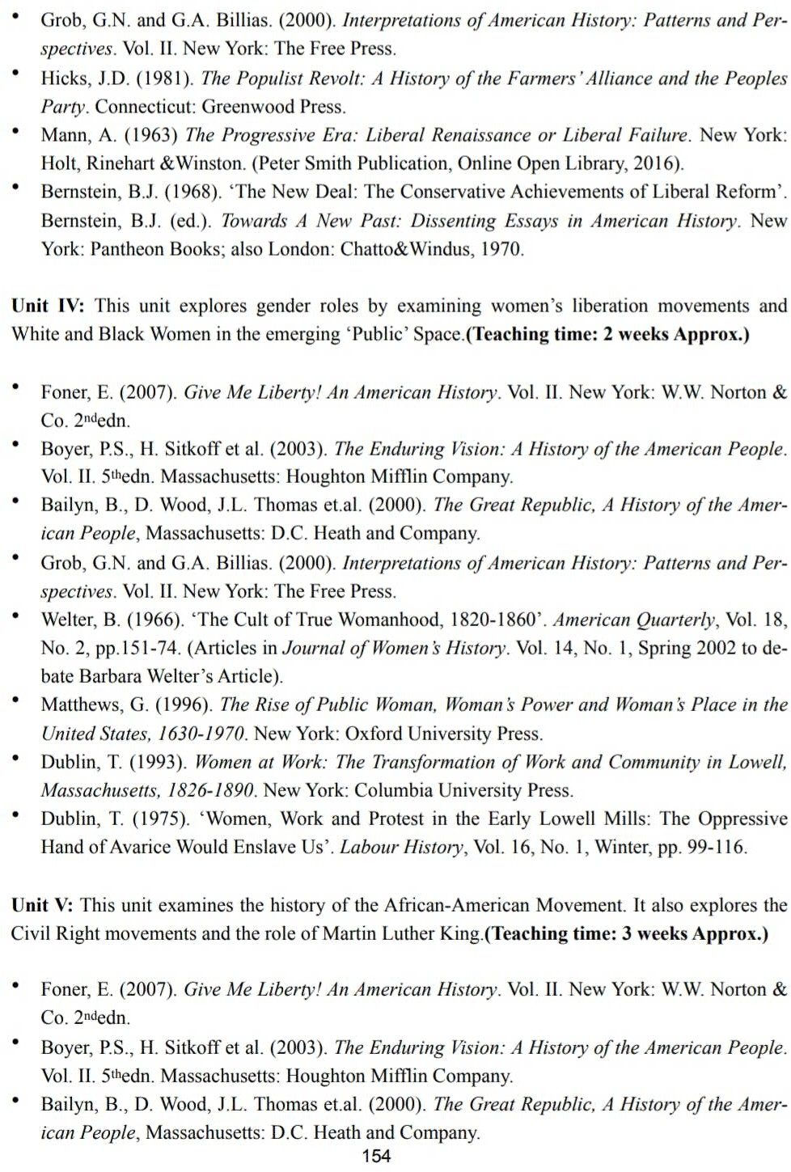

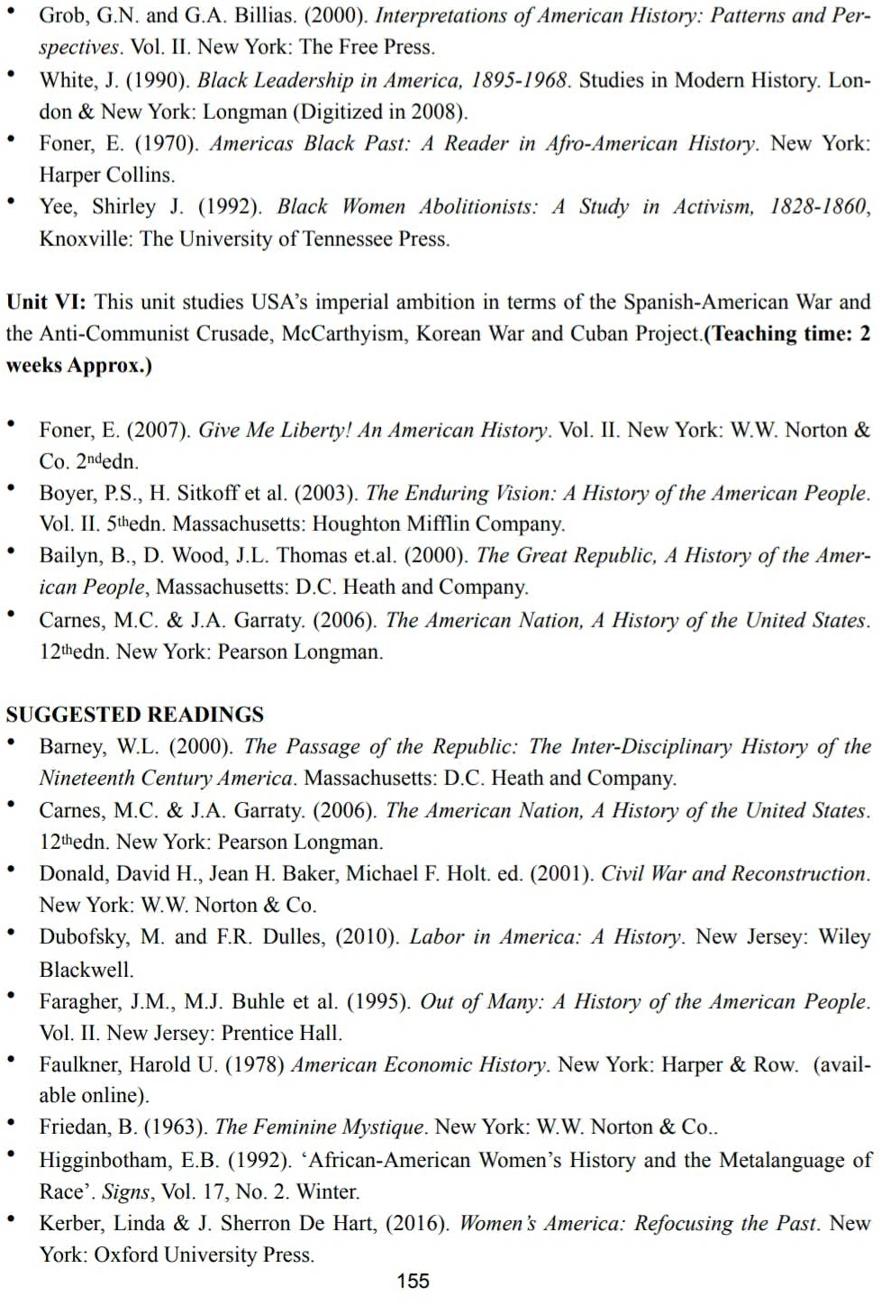

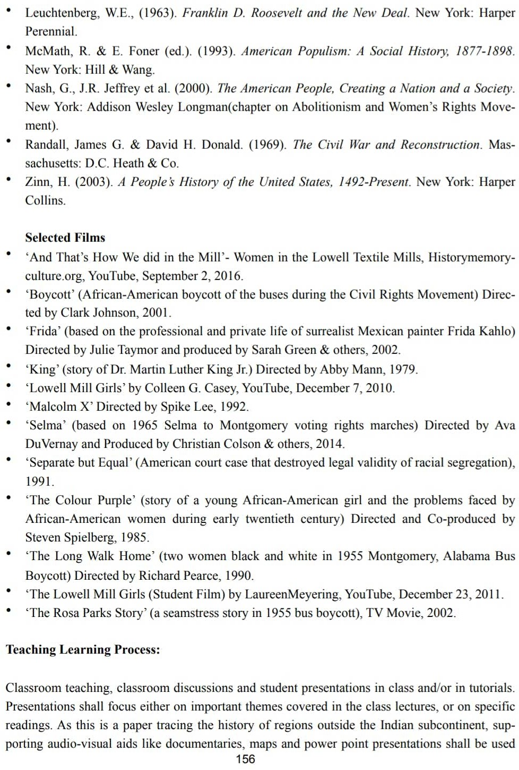

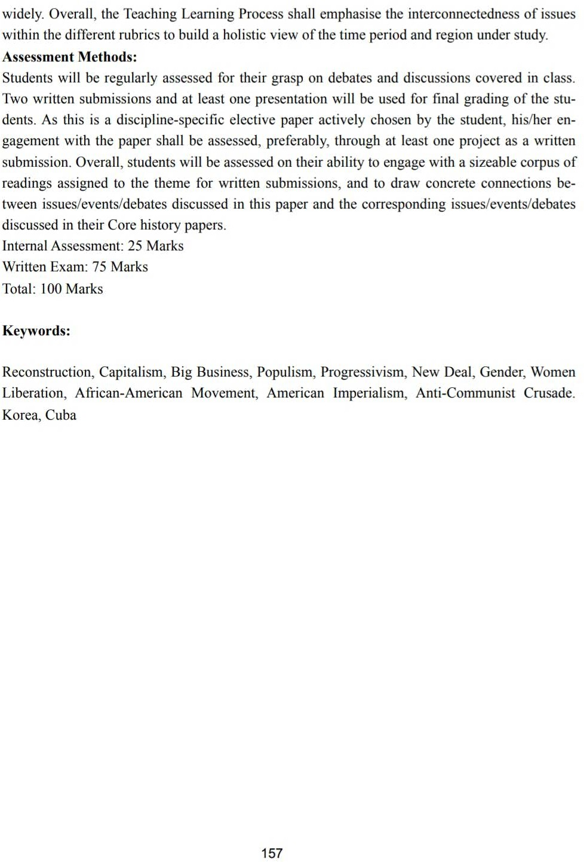

**ASSESSMENT METHODS:**

* Assessment will be done according to the guidelines university

**Internal Assessment: 25 Marks**

Internal Assessment: 25 marks

Quizzes on specific topics will be organized after discussion with students.

Written Exam: 75 Marks

Total: 100 Marks