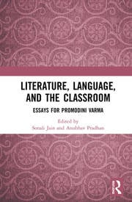

[Enlarge](https://images.routledge.com/common/jackets/amazon/978036747/9780367479640.jpg)

SAVE  
£24.00

**1st Edition**

Literature, Language, and the Classroom  
Essays for Promodini Varma

*Edited By*

[*Sonali Jain*](https://www.routledge.com/search?author=Sonali%20Jain)

*,*

[*Anubhav Pradhan*](https://www.routledge.com/search?author=Anubhav%20Pradhan)

Copyright Year 2022

**Hardback**  
₹995.00

**eBook**  
£29.59

* This format of the title is only available for local purchase in India, Pakistan, Nepal, Bhutan, Bangladesh and Sri Lanka.

ISBN 9781032233529

Published September 8, 2021 by Routledge India

174 Pages

* [Available on Taylor & Francis eBooks](https://www.taylorfrancis.com/books/9780367479640)

URL <https://www.taylorfrancis.com/books/edit/10.4324/9781003049777/literature-language-classroom-sonali-jain-anubhav-pradhan>