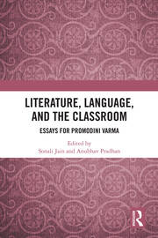

Chapter

Holding Environments

An enquiry into institutional minds

*By Sonali Jain*

Book [Literature, Language, and the Classroom](https://www.taylorfrancis.com/books/mono/10.4324/9781003049777/literature-language-classroom?refId=a1a6313f-b390-4db6-88b3-7658af03b29d&context=ubx)

Edition 1st Edition

First Published 2021

Imprint Routledge India

Pages 13

eBook ISBN 9781003049777

**ABSTRACT**

The human psyche affects institutional management and performance. The dynamics of higher educational institutions are a key consideration in discussing the future of higher education. This chapter sets out to study under a wide net all-women’s undergraduate colleges in Indian metropolises as exemplars on the psychoanalytic couch. As far as possible, most group and individual processes in these educational institutions are placed under the classical psychoanalytic lens, and how the unconscious plays a major role in teaching and learning is examined. The theoretical framework is provided by the works of Sigmund Freud, Melanie Klein, Manfred Kets de Vries, Nancy Chodorow, Sudhir Kakar, Salman Akhtar, D.W. Winnicott, and Wilfred Bion.

URL <https://www.taylorfrancis.com/chapters/edit/10.4324/9781003049777-8/holding-environments-sonali-jain>