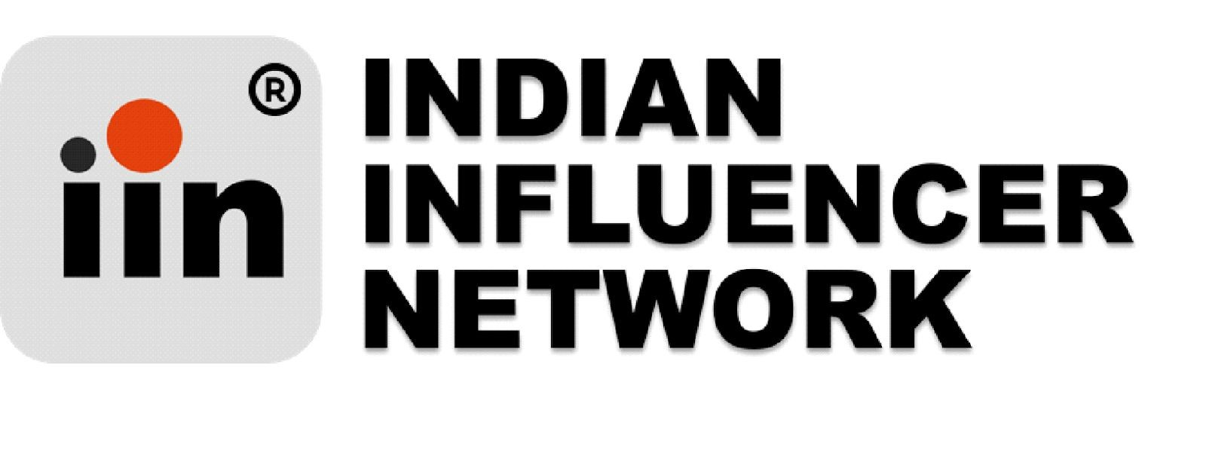

**04/09/2020**

**Unnati tandon**

Dear Unnati,

We are pleased to offer you the position of Intern at Indian Influencer Network (Legal Name : Alt360 Media ) with a start date of 07/09/2020 for a duration of 2 months, contingent upon submission of all signed copy of this letter. Your reporting manager will be assigned to you at the time of onboarding with our organization. We believe your skills and experience are an excellent match for our company.

In this role, you will be required to perform tasks in data research, marketing and inside sales.The monthly will be Rs.10,000 per month for this role​ .​

Please confirm your acceptance of this offer by signing and returning this letter by 3rd day of receiving the same.

We are excited to have you join our team! If you have any questions, please feel free to reach out at any time.

* 



**Sincerely**



**Abhishek Singh**

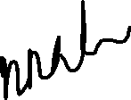

**Date: 04/09/2020**



FC-111, SF, Tagore Garden, New Delhi - 110027