Chilman Photos

Chilman’s performane of Kali Salwar, Abhivyakti 2017

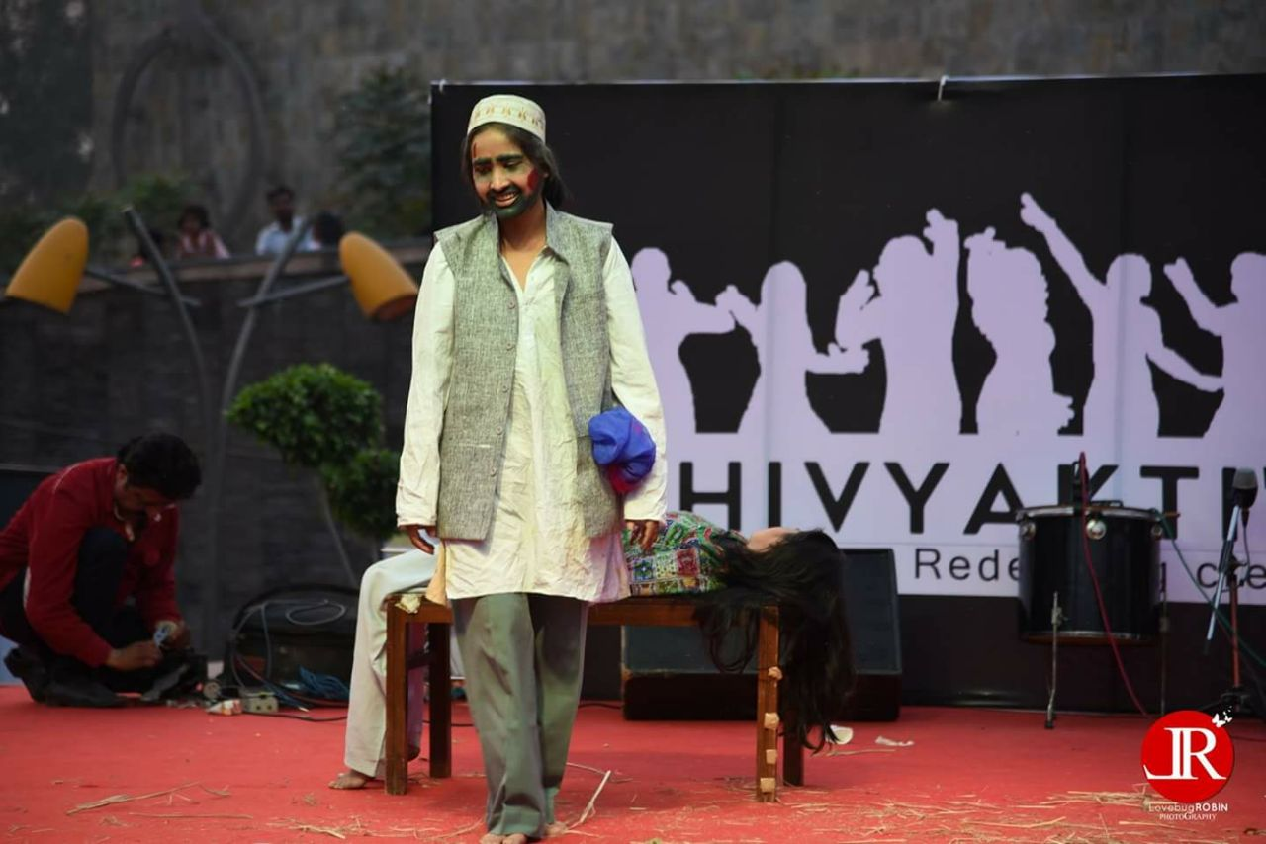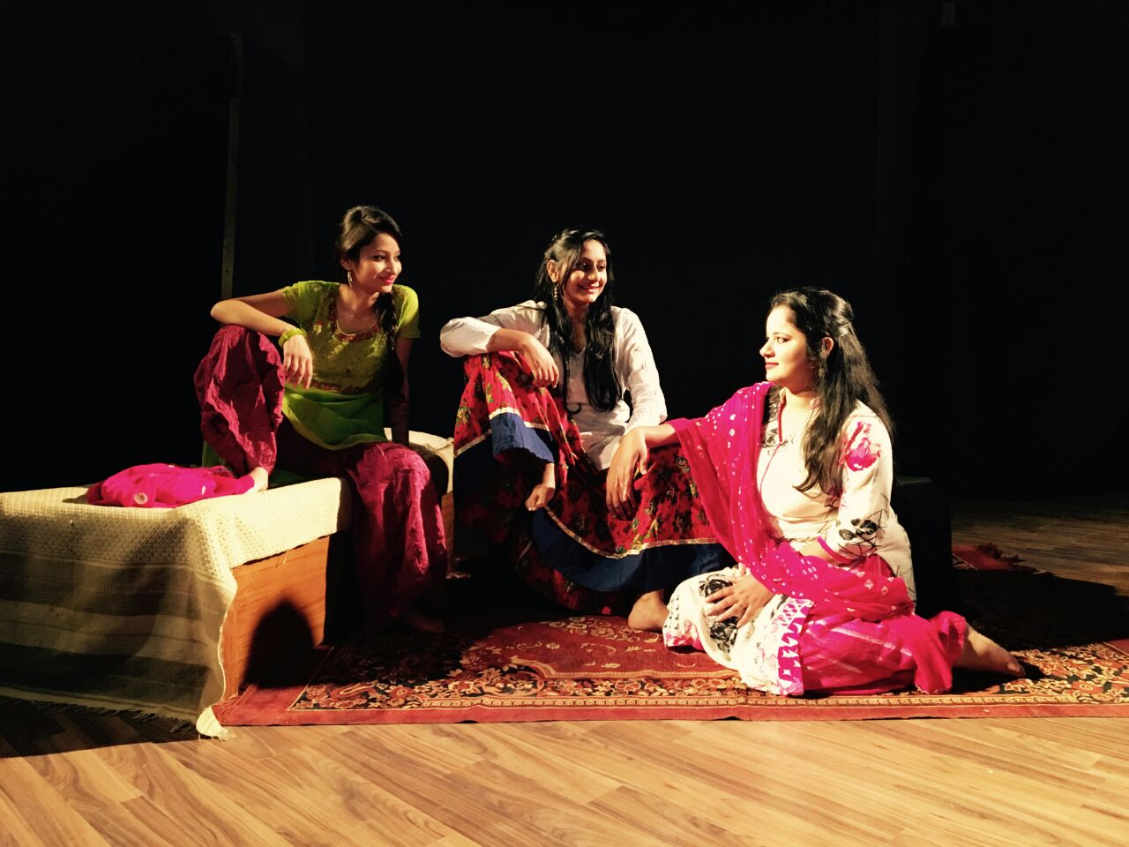

A False Woman’s Love, 2019

