**ELANTRE SOCIETY**

ELANTRE

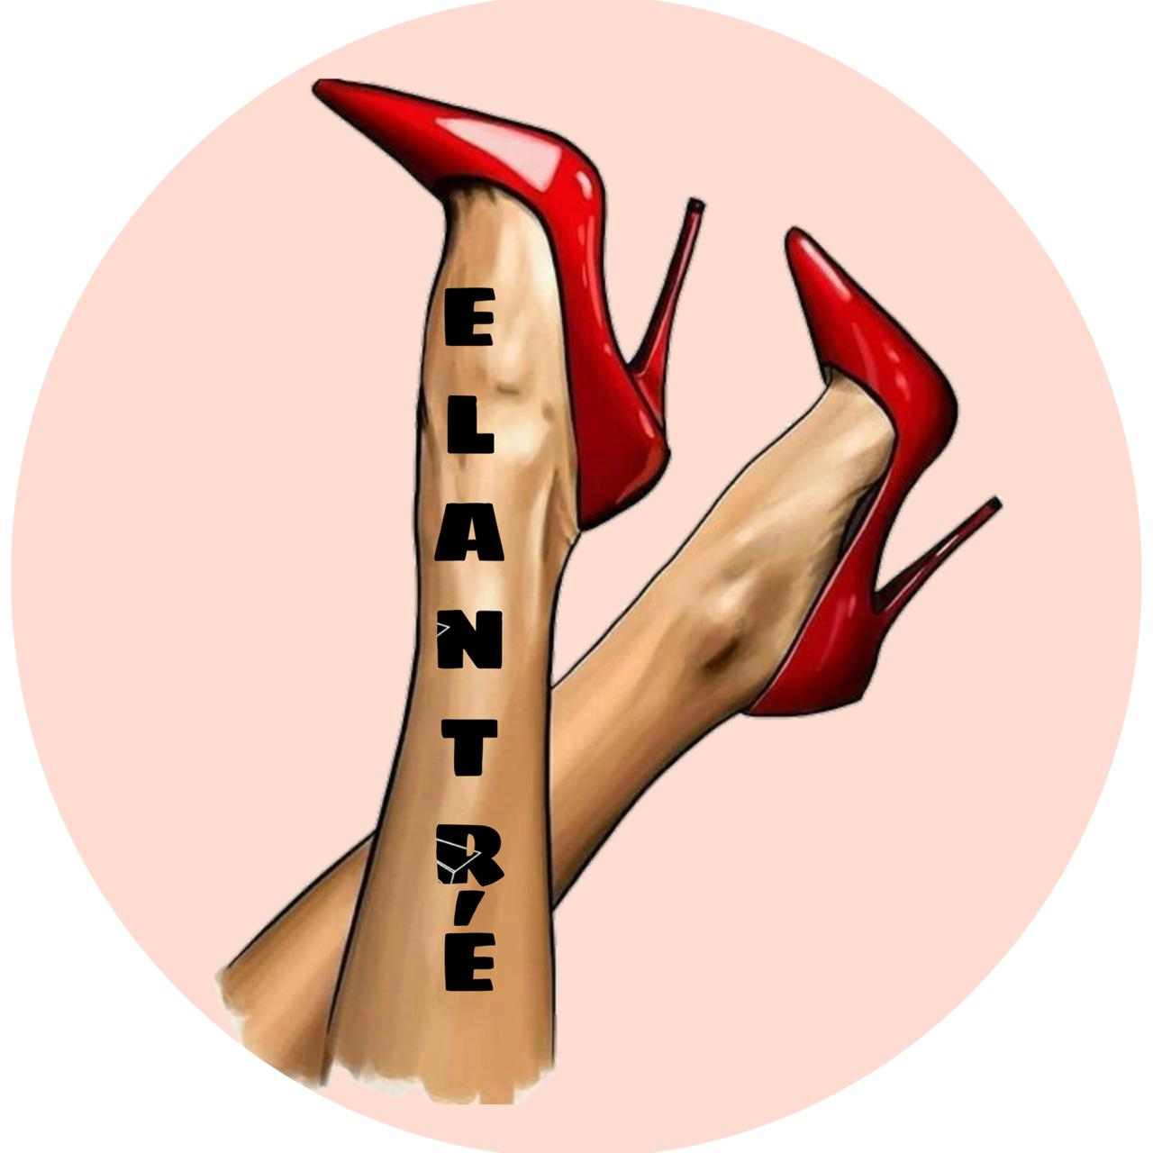

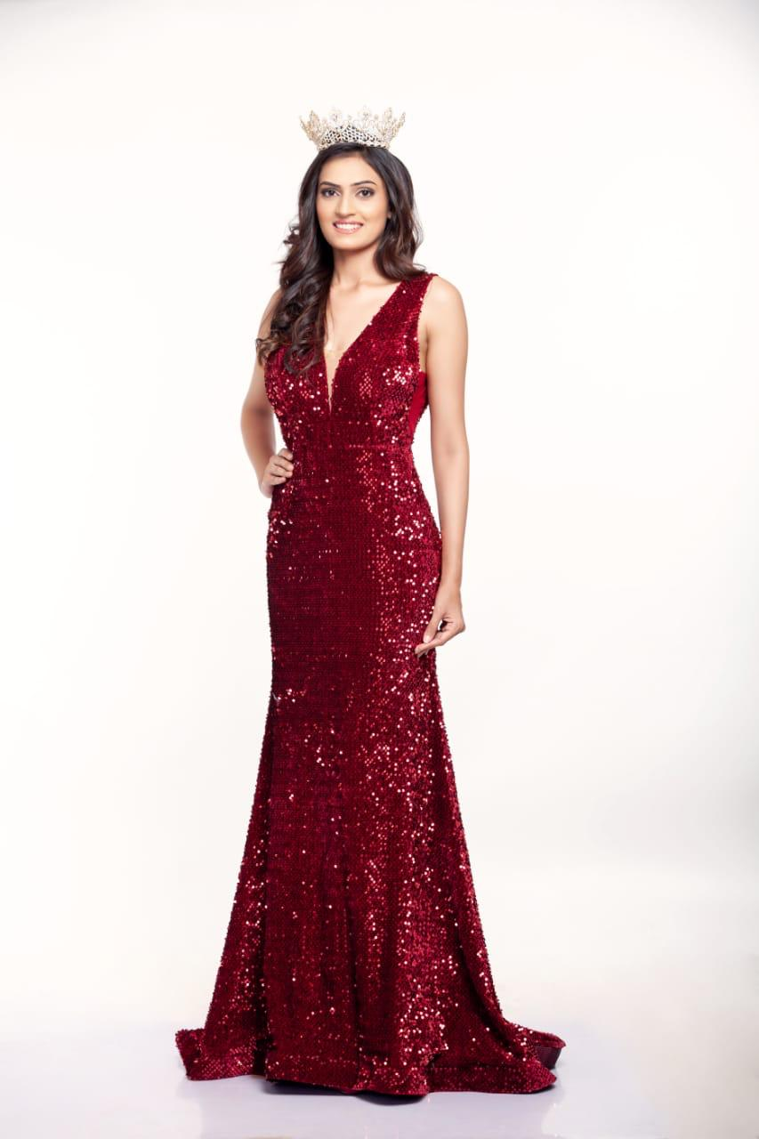

elantre work\Testimony by Ms. Nishi Bharadwaj_Ms. Earth.mp4

**2015-16**

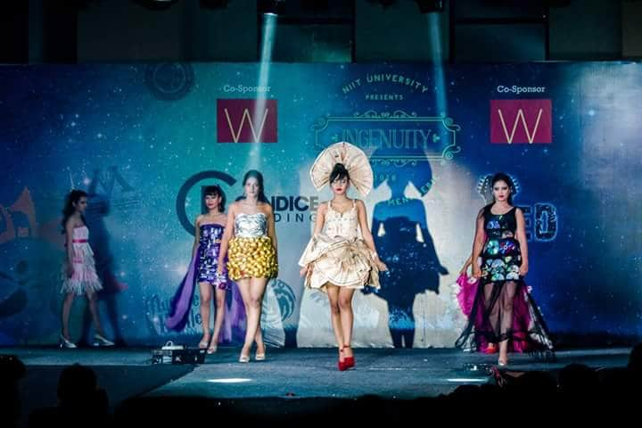

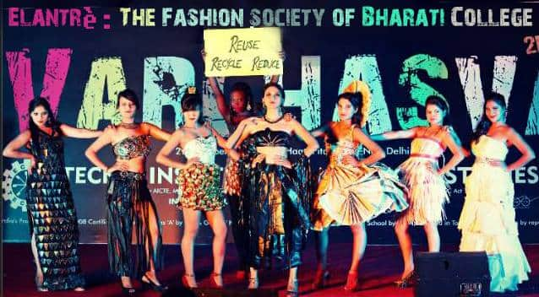

<https://youtu.be/_184fb0Ymtg>

***Video from fashion show at Bharati College, 2016***

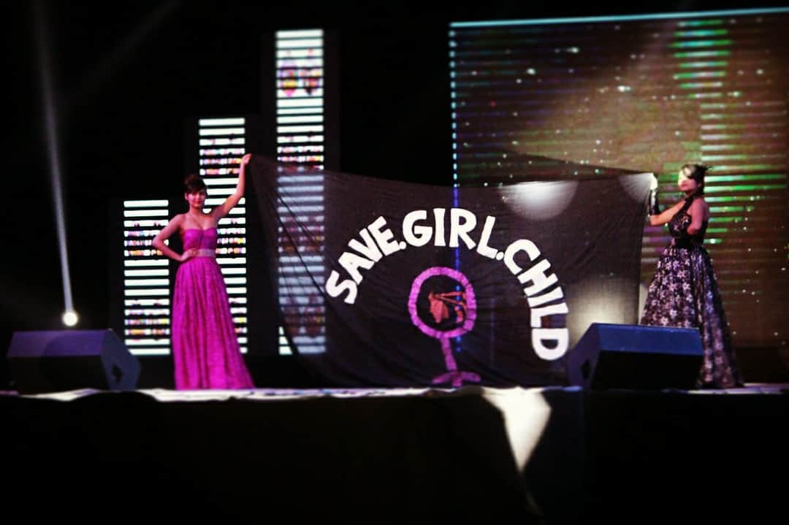

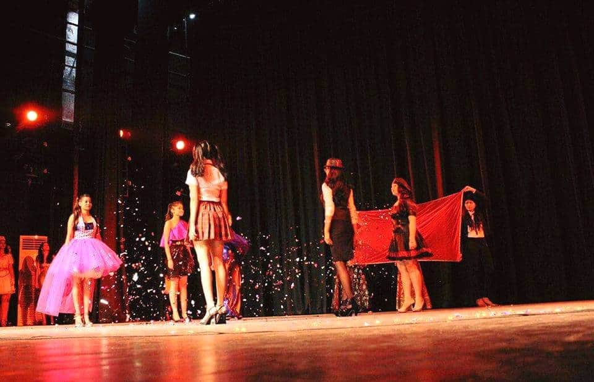

In **2017-19**

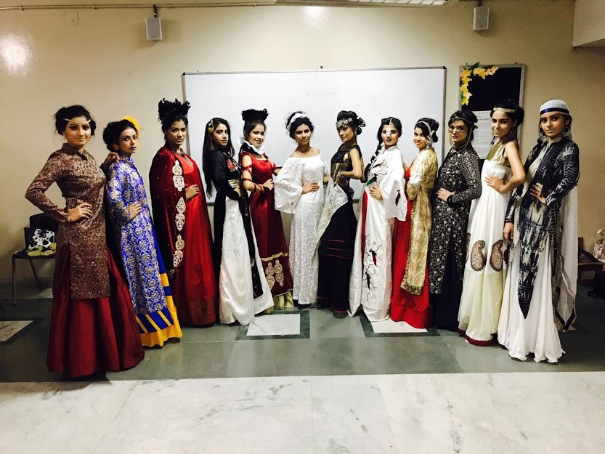

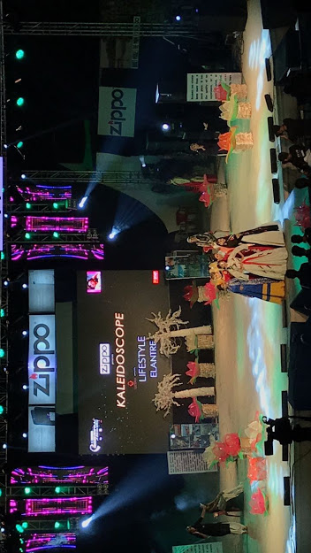

a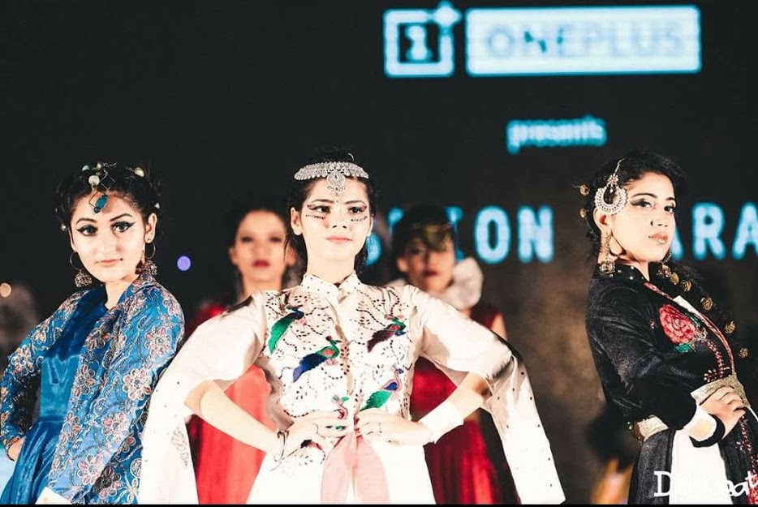

<https://photos.app.goo.gl/e4WTpEtLqjKGFQYw5>

***Video from fashion show at Sri Aurobindo College, University of Delhi***

In **2019-20**

