Debate Competition on ”Vigilance takes away freedom” in association with LIC

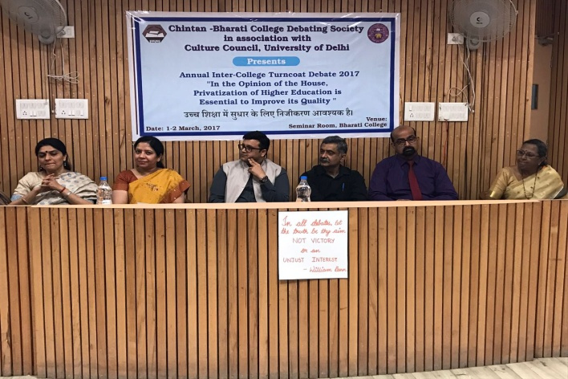

Annual Inter-college Turncoat Debate in association with Culture Council, DU

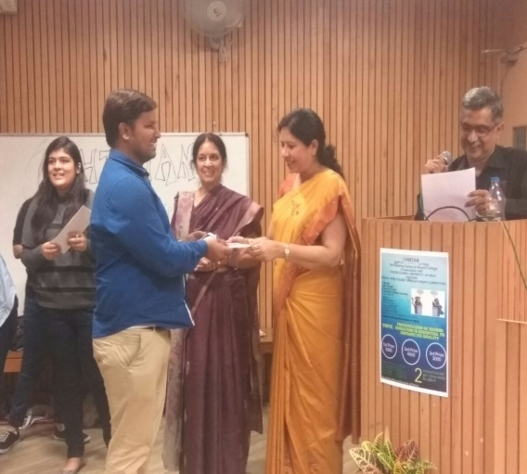

LIVE TALK on Kashmir- Background and Future Prospects was delivered by Major General (Retd.) Balraj Mehta

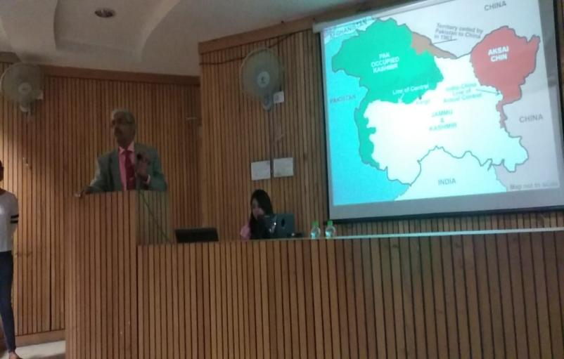

LIVE TALK- Ms. Swati Chawla from the University of Virginia spoke on the Tibetan Exile in India.

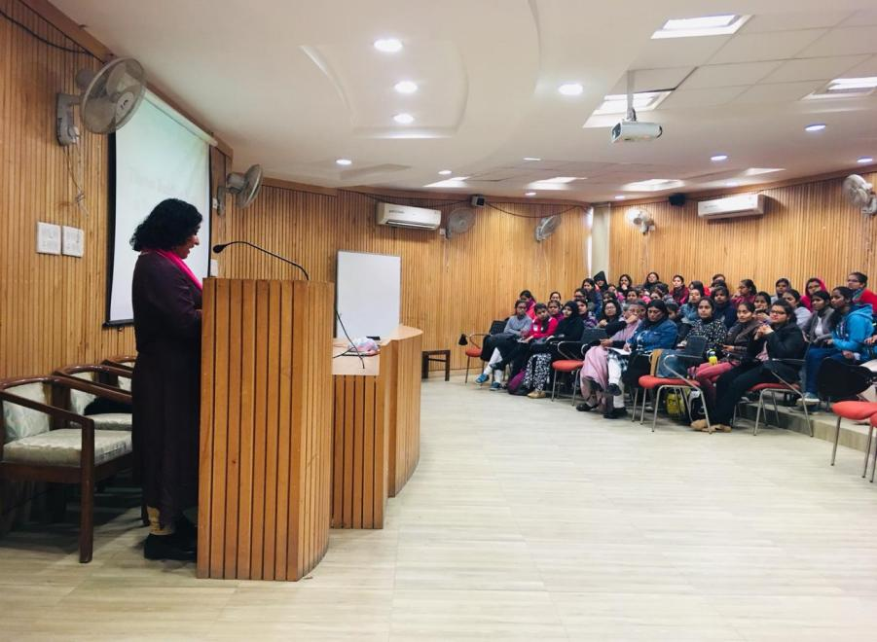

Annual Intercollege Debate

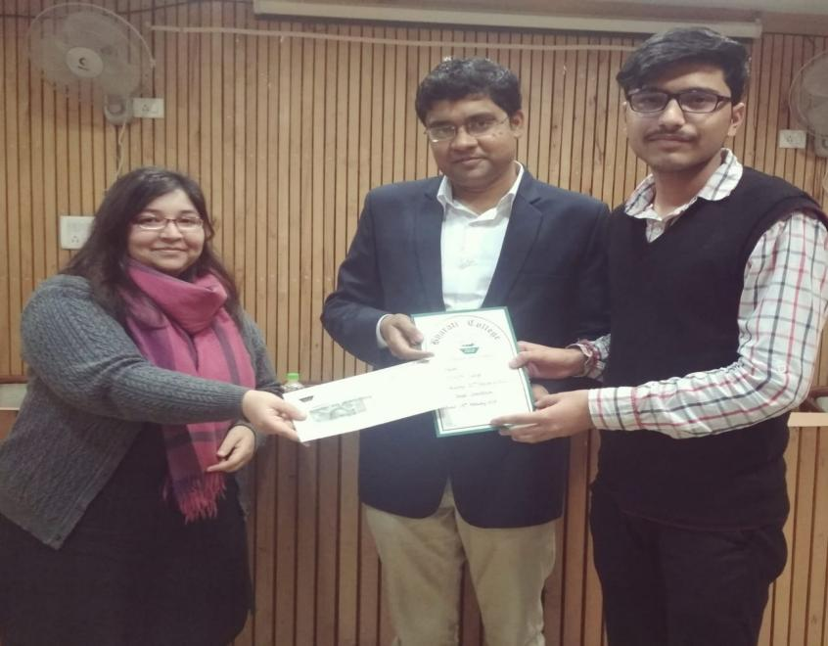

Quiz Competition by Chintan in association with DAIC, Ministry of Social Justice and Empowerment

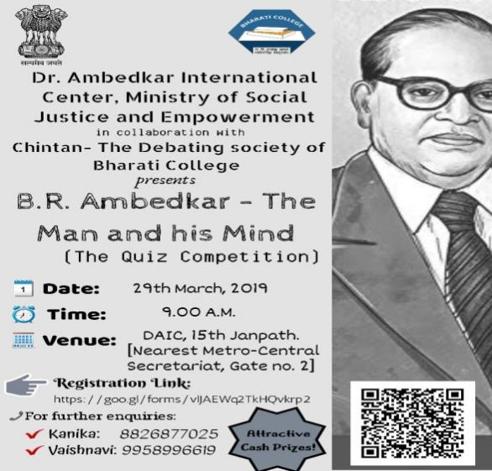

Training session on public debating

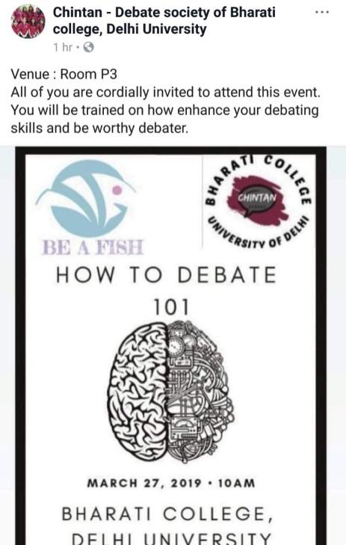 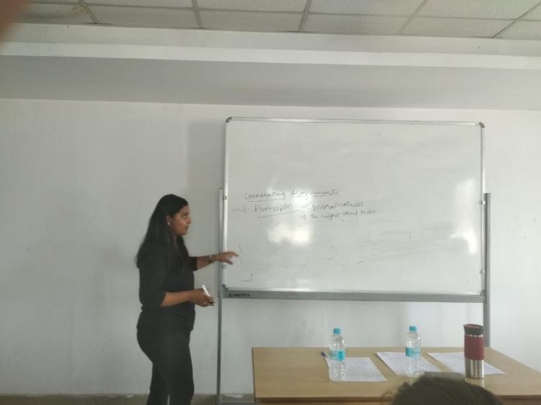

Live Talk by Aryan Mishra (founder of Spark Astronomy. Tedx speaker

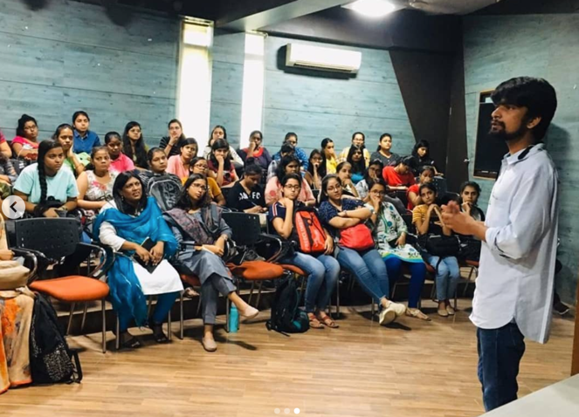

Youth Declamation competition- by Chintan in collaboration with Ministry of Youth Affairs and Sports

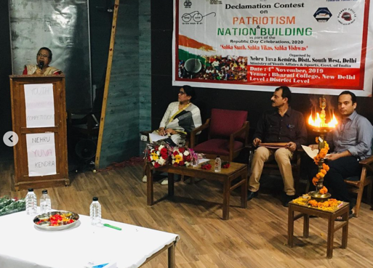 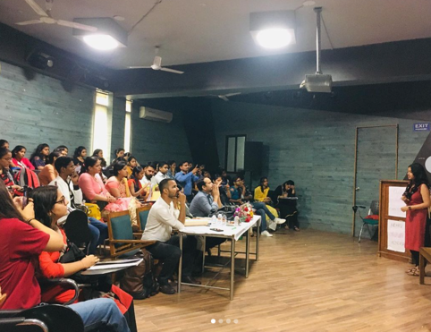

Annual Intercollege Debate

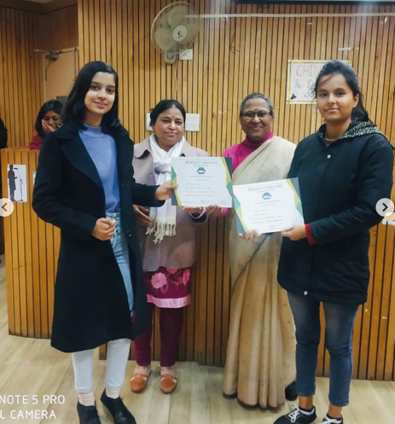 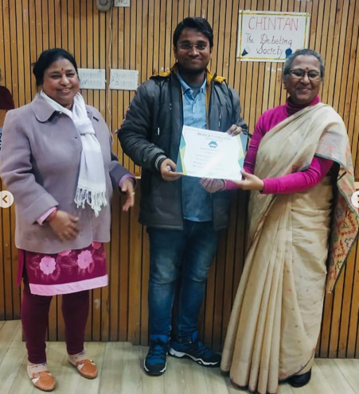

Open Mic Competition by Chintan in collaboration with The Secular House

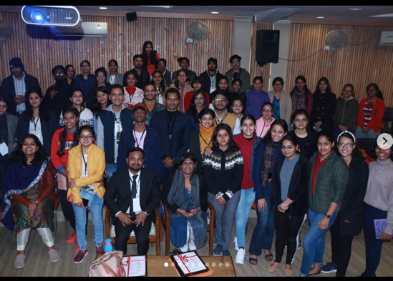 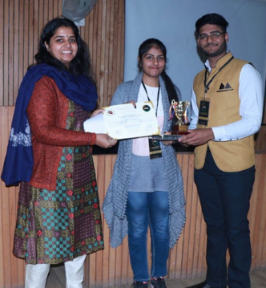

Online Oratory competition- SPEECHES THAT SHOOK THE WORLD

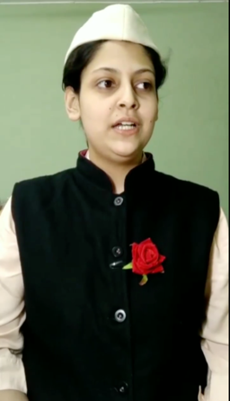 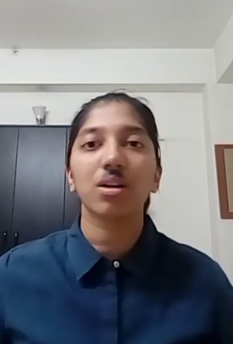

5